**Installing ML tools for Ubuntu 16.04 Linux**

**on Dell Precision 5820 Tower PC**

**(ver 1.8, 7 Jan 2019)**

**Daniele Bagni**

**DSP / ML Specialist for EMEA**

**Contents**

**HISTORY** 2

**WARNING: read it before starting, please!** 3

**1.0** **Machine Learning SW specification** 4

**2.0** **Dell Precision 5829 Tower PC specifications** 6

**3.0** **BIOS setup** 7

**4.0** **Booting the PC from a Linux USB stick** 9

**5.0**  **First problems: VGA resolution and no Ethernet connection** 10

**5.1 Ethernet Connection** 12

**5.2 VGA default monitor** 13

**5.3 Connect target ZCU102 board to Linux host PC with cables** 15

**6.0**  **Installing NVIDIA Quadro P6000 GPU driver** 17

**7.0** **Installing NVIDIA CUDA libraries** 18

**7.1 CUDA-8.0 ToolKit** 18

**7.2 cuDNN 7.0.5** 21

**7.3 NCCL1** 22

**7.4 CUDA-9.1 ToolKit (optional)** 23

**7.5 cuDNN 7.0.5 for CUDA toolkit 9.1 (by J. Cory, also checked by me)** 24

**8.0** **Create your Python2.7 Virtual Env. with ML-related packages** 25

**8.1 Content of caffe_py27_requirements.txt file** 25

**8.2 Install other packages needed by Caffe, included openCV 2.4** 27

**8.3 How to install openCV 3.3 from scratch (optional)** 29

**8.4 File install_caffe*.sh** 29

**9.0** **Install Caffe-SSD-Ristretto** 31

**9.1 Script to activate the virtual environment** 32

**9.2 Install Ristretto** 33

**9.3 Possible build errors** 34

**10.0** **Shortcut for last two sections** 36

**11.0** **Install DeePhi’ tools** 36

**11.1 Installing and running the DeePhi HOST tools on AWS** 41

# **HISTORY**

* **1v4.** Added the WARNING page and the new Sections 10.0 and 11.0
* **1v6.** Corrected some typo errors, added PuTTY, added NCCL1.0 (thanks to Giovanni Guasti and Mark Harvey for their review).
* **1v7.** Updated section 11 to the newest DeePhi dnndk_v2.07 release (thanks to Giovanni Guasti and Antonello Di Fresco and Jon Cory for their review)
* **1v8.** Updated to the newest DeePhi 2.0.8 DNNDK release and added Subsection 11.1

# **WARNING: read it before starting, please!**

Installing **Caffe framework for ML development** can be really a painful and time consuming process, especially if you want to use your NVIDIA GPU to fasten the simulation time, which is basically mandatory as Caffe compiled with CPU is extremely slow and you cannot practically use it with “normal” CNNs. This is why I have written this document, after having installed Ubuntu 16.04 from scratch at least 5-6 times and Caffe at least 10-12 times: I would like you to save your time and not feel the pain I had to. Therefore it is very important that you follow what written here in a disciplined way.

Note that I have selected **Python2.7 and OpenCV 2.x** to make life easier, you can change them at your own risk.

**Sections 2 to 5** of this document explain you how to install correctly Ubuntu 16.04, you cannot skip them.

**Sections 6 - 7** explain you how to install your GPU driver and the CUDA and cuDNN libraries, you cannot skip these sections too. In particular in this document I have selected **CUDA 8.0** libraries as they are compatible with Caffe, TensorFlow and DeePhi tools. But nobody prevents you to install both CUDA 8.0 and 9.0, all in all they are placed in different folders and can live together (I did it in another PC). Most of the problems you might find about these libraries, once installed, is to make them visible, so check the environmental variable **$LD_LIBRARY_PATH** in your **.bashrc** Linux configuration file.

**Sections 8 - 9** explain you how to install Python virtual environment and Caffe (or its forks). These are the most difficult sections. Please skip then the first time.

**Section 10 is a shortcut based on a script that should execute everything for you**: that script is just doing automatically what explained in the Sections 8 and 9. If it fails, you have to go to those Sections and see in more details what to do step by step. Note that Section 10 relies on a small archive into which I have put the correct **Makefile** and **Makefile.config** files to avoid you any further editing on original Caffe files.

**Section 11** explains you how to install **DeePhi tool for quantization**. You cannot skip it.

In case of errors, I strongly recommend you to copy and paste the error message on Google: 90% of the time a page from Stack Overflow website (<https://stackoverflow.com>) will appear with possible solutions. Also check the other fundamental environmental variable: **$PYTHONPATH.**

Last but not least, please note that there is a big difference in installing a Linux package with “**sudo apt-get install”** or with “**pip2 install”**: the first command puts everything in the /usr/lib and /usr/local/lib/ which are folders visible by any user, but the second puts everything in a python virtual environment which is hidden and it becomes visible only if you activate it with the workon command. So packages installed with the first command must be installed only once forever, but packages installed with the second command must be installed per each python virtual environment you have.

I tried to do at my best to manage different python virtual environments in a clean way, I hope you will enjoy it.

*Daniele Bagni*

# **Machine Learning SW specification**

This document tries to explain how installing ML SW environments as **Caffe** and **TensorFlow/Keras** on a Dell Precision 5820 Tower Desktop PC. Instead of Caffe you will install **Ristretto** and **Caffe-SSD-Ristretto**, both are forks of Caffe which have to be used together with the **Xilinx CHaiDNN**  on an **Ubuntu 16.04 LTS** (Xenial) Linux PC. In particular Ristretto is a public domain fork on github, while Caffe-SSD-Ristretto is an internal Xilinx github project suitable for Object Detection with SSD.

The dependencies of Caffe on a lot of Linux packages can make the install and compilation processes very painful and time consuming.

All the material of this document is based on the following main webpages (here listed for your reference) which are the best explained ones among the several pages available on Internet on this subject, according to my experience.

* <https://gl-research.com/caffe/ristretto/wikis/home>
* <https://github.com/BVLC/caffe/wiki/Ubuntu-16.04-or-15.10-Installation-Guide>
* <https://www.pyimagesearch.com/2016/10/24/ubuntu-16-04-how-to-install-opencv/>
* <https://www.pyimagesearch.com/2017/09/27/setting-up-ubuntu-16-04-cuda-gpu-for-deep-learning-with-python/>
* <http://docs.python-guide.org/en/latest/dev/virtualenvs/>
* <https://github.com/BVLC/caffe/wiki/OpenCV-3.2-Installation-Guide-on-Ubuntu-16.04>
* <https://gist.github.com/arundasan91/b432cb011d1c45b65222d0fac5f9232c>
* <https://groups.google.com/forum/#!topic/ristretto-users>
* https://github.com/BVLC/caffe/issues/5793

Furthermore, DeePhi requires the host (PC) side of its ML toolchain to be compatible with:

* ubuntu 16.04 + cuda 8.0 + cuDNN v7.0.5
* ubuntu 16.04 + cuda 9.0 + cuDNN v7.0.5
* ubuntu 16.04 + cuda 9.1 + cuDNN v7.0.5

Caffe 1.0 BVLC, Caffe-Ristretto and Caffe-SSD-Ristretto require:

* python 2.7

TensorFlow-GPU 1.4.1 requires:

* either python 2.7 or python 3.5
* cuda 8.0

**In my case I have selected cuda 8.0 because I could have both TensorFlow and Caffe in the same virtual environment**.

# **Dell Precision 5829 Tower PC specifications**

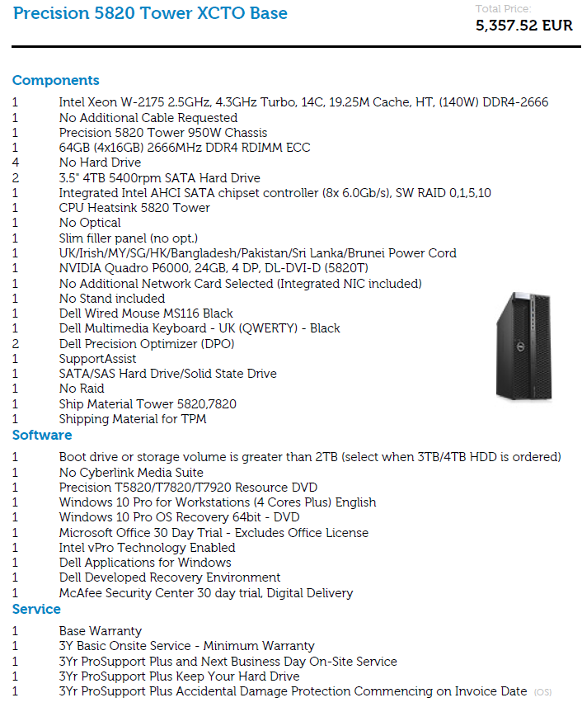

# **BIOS setup**

Enter into the BIOS menu of the PC by pushing **F2 or F12 key** during the PC bootstrap and set the items illustrated in the following Figures 1, 2,3,4, 5:

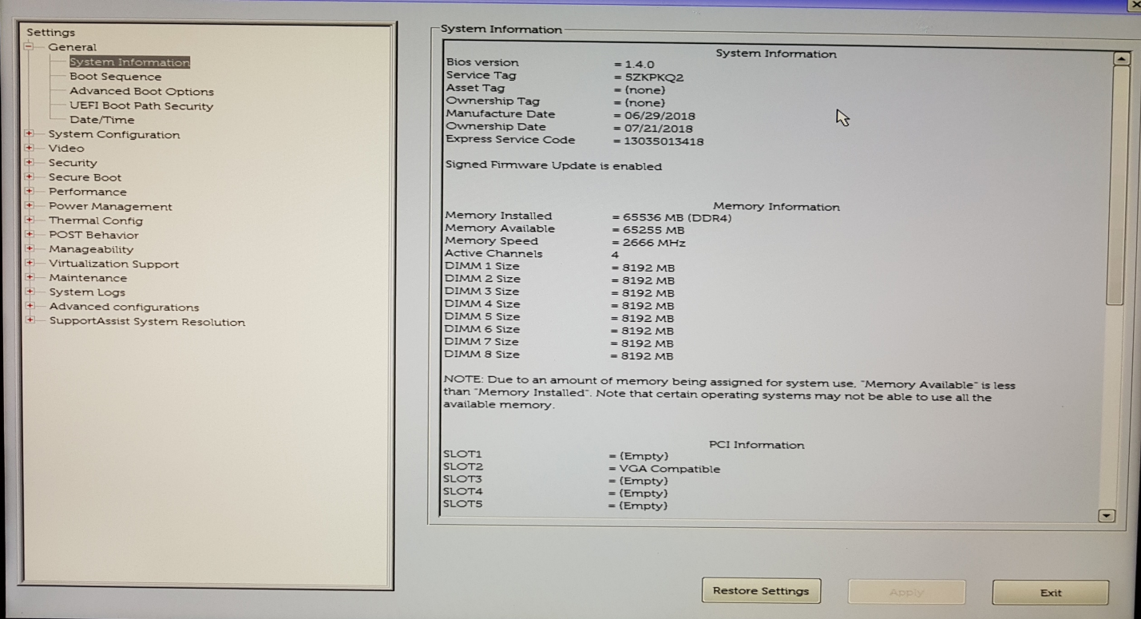

Figure 1: BIOS setup, System Information page 1

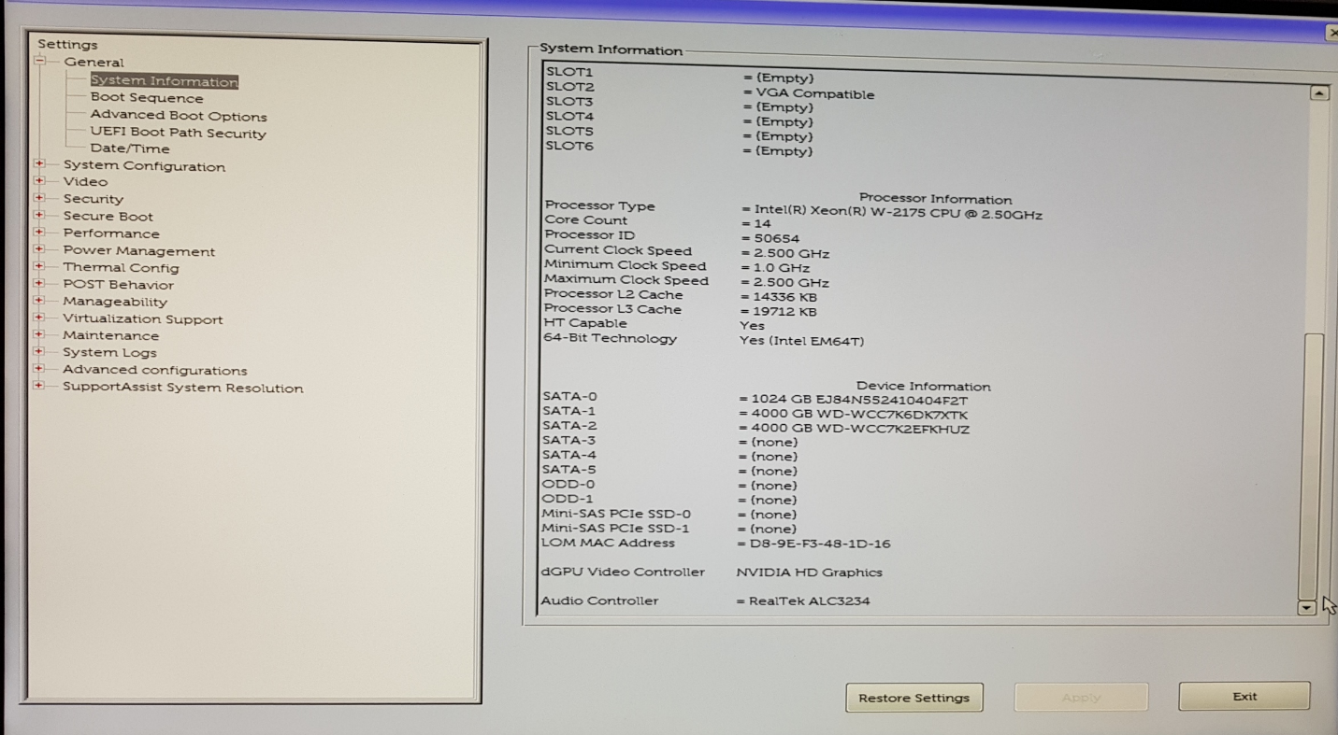

Figure 2: BIOS setup, System Information page 2

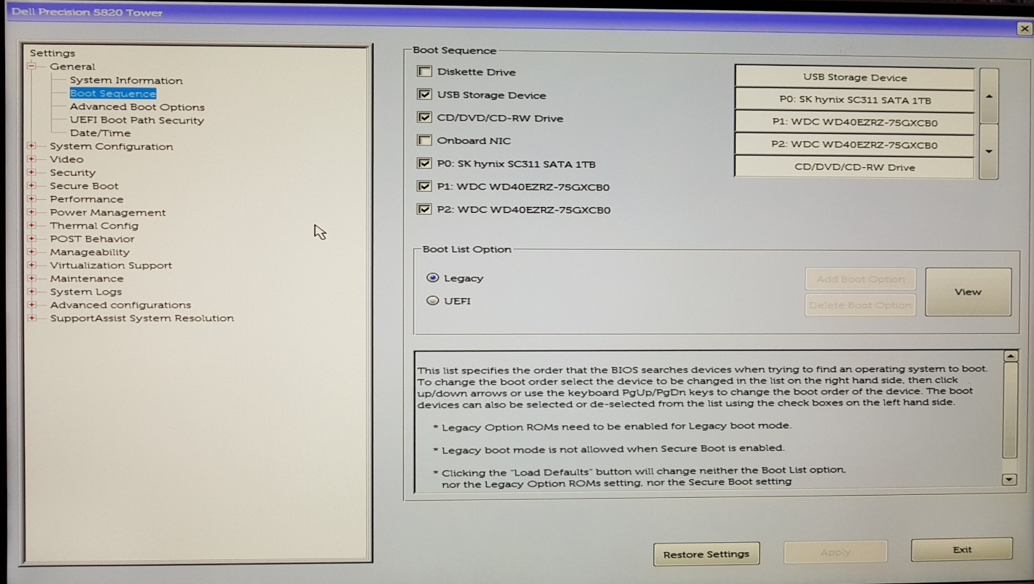

Figure 3: BIOS setup, Boot Sequence page

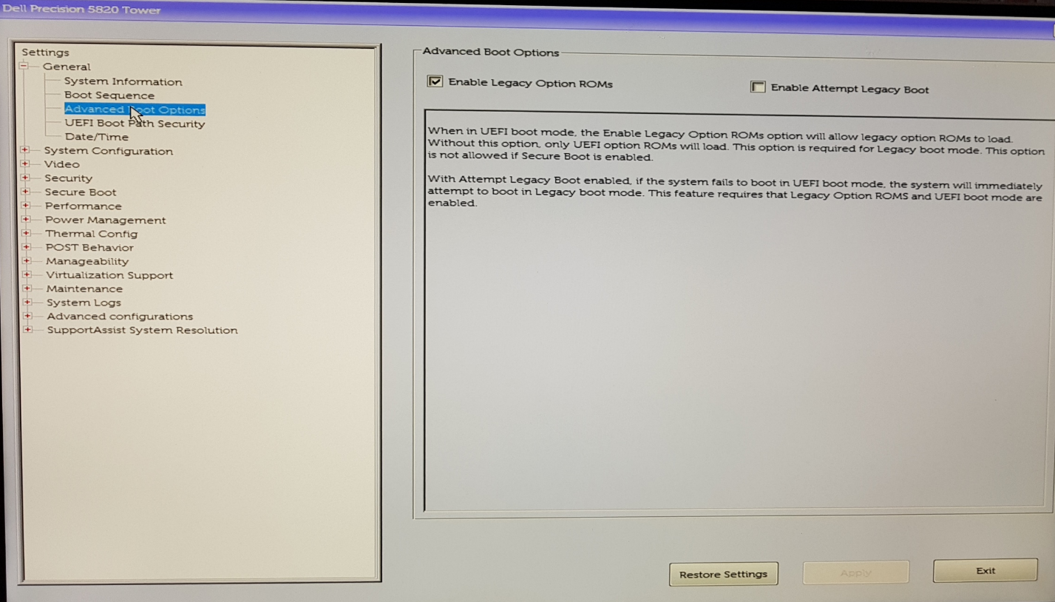

Figure 4: BIOS setup, Advanced Boot Options page

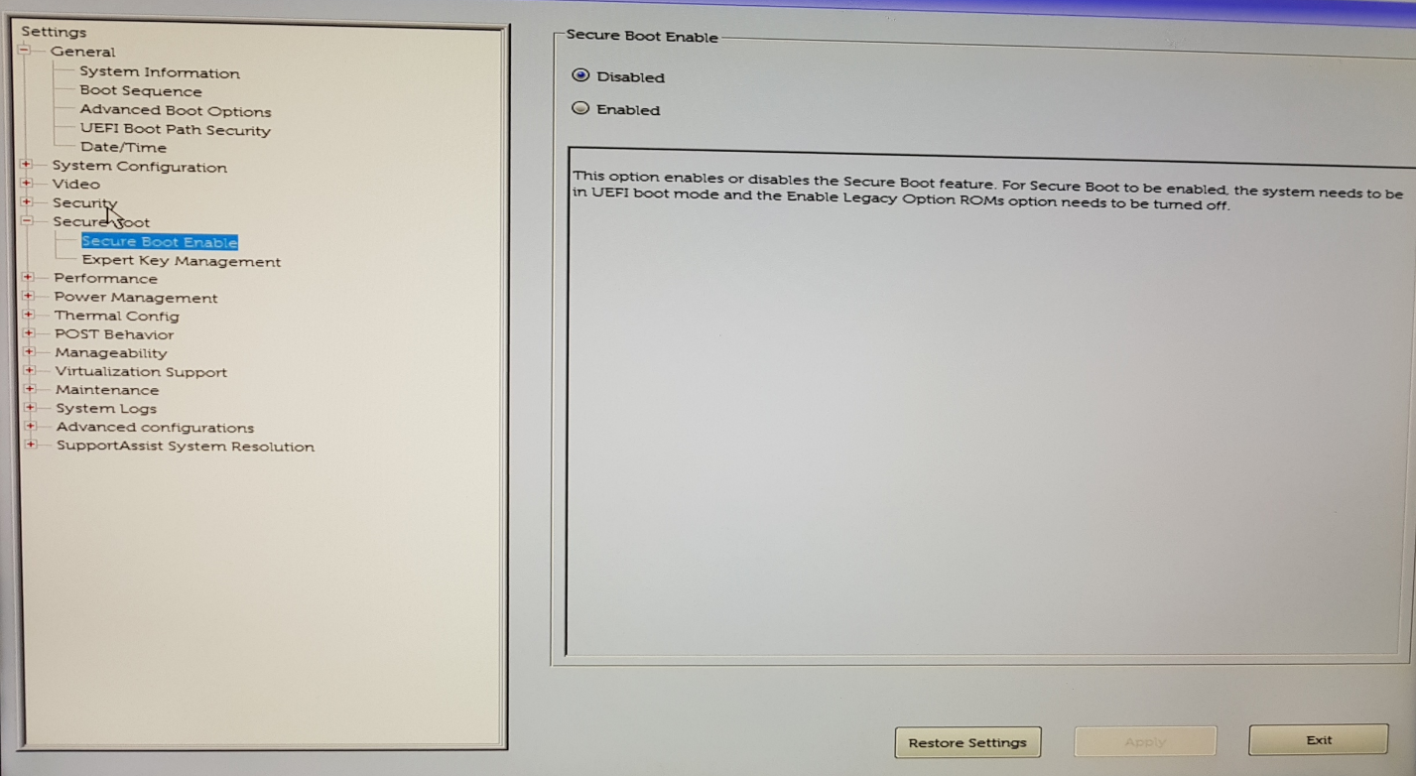

Figure 5: BIOS setup, Secure Boot Enable page

# **Booting the PC from a Linux USB stick**

1. Download the **ubuntu-16.04.1-desktop-amd64.iso** image from

<http://old-releases.ubuntu.com/releases/16.04.1/>

1. Prepare a USB stick to boot the PC from it with Ubuntu, according to what written here <https://help.ubuntu.com/community/Installation/FromUSBStick>.

You first have to download the Linux Live USB creator executable from <http://www.linuxliveusb.com/en/help/guide/preparation> and set it according to what illustrated in Figure 6.

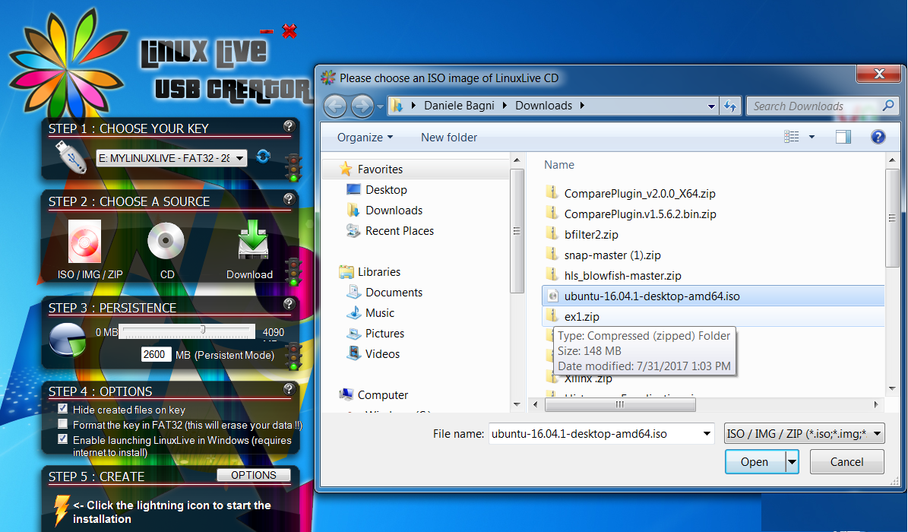

Figure 6: settings of Linux Live USB Creator GUI.

# **5.0 First problems: VGA resolution and no Ethernet connection**

I immediately had 2 major problems after having installed Ubuntu overwriting completely Windows-10: no connectivity with my Ethernet WLAN board (so basically no connection to Internet) and the default monitor forced to VGA resolution which makes impossible to use the GUI, being the desktop image size much larger than the whole screen of my monitor (so you cannot click on some tags of the various windows). I had to switch to terminal command line with **CTRL-ALT-F1** keys.

Before solving the Ethernet connection missing, I did the following actions, which are anyway good in general.

The Ethernet port name for the machine is using a new format instead of the traditional Linux names “eth0, eth1, eth2”and so on.

I therefore looked at <https://www.xilinx.com/support/answers/60510.html> and <https://askubuntu.com/questions/767786/changing-network-interfaces-name-ubuntu-16-04>

and I ended up with the following solution:

* the file **/etc/udev/rules.d/70-persistent-net.rules** now has to be created manually. The line for fixing the interface name of the NIC with for example a MAC address like "02:01:02:03:04:05" to "eth0" is now:

SUBSYSTEM=="net", ACTION=="add", DRIVERS=="?*", ATTR{address}=="02:01:02:03:04:05", ATTR{dev_id}=="0x0",

ATTR{type}=="1", NAME="eth0".

This line looks nearly the same as in Ubuntu 14.04 LTS with one slight difference: In Ubuntu 14.04, there was the additional condition KERNEL=="eth*". For some reason, this does not work in Ubuntu 16.04 LTS. If this additional condition is present, the whole line is ignored and you are back to the default behavior (as specified in 80-net-setup-link.rules).

* Modify the file **/etc/network/interfaces** as shown in Figure 7 screenshot (right side).
* edit your **/etc/default/grub** changing the line from
  + GRUB_CMDLINE_LINUX="" to
  + GRUB_CMDLINE_LINUX="net.ifnames=0 biosdevname=0"
  + and, finally:
  + sudo update-grub
  + and reboot your system:
  + sudo reboot

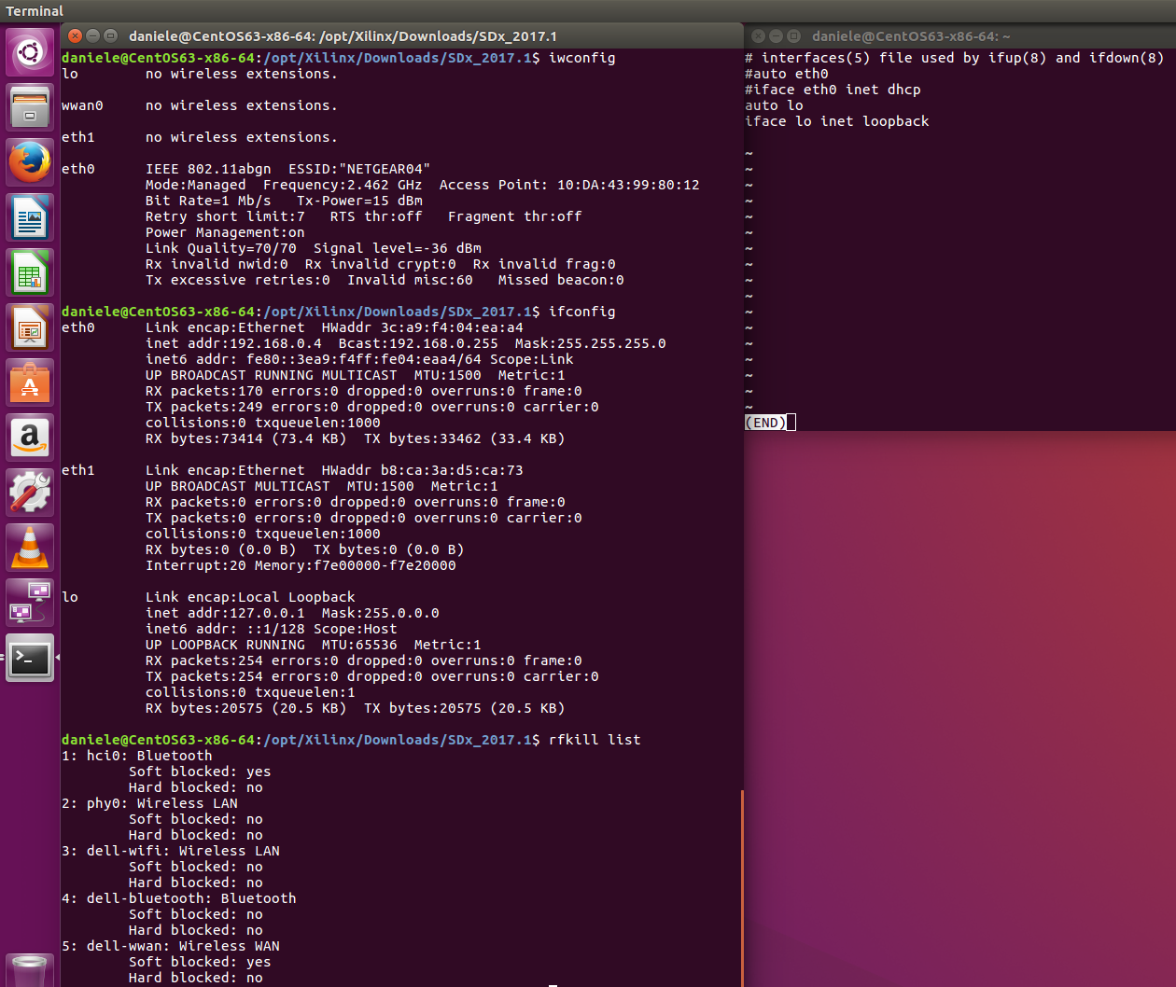

Figure 7: on the left some interesting Linux “radio” commands, on the right the /etc/network/interfaces file content

## **5.1 Ethernet Connection**

The following Linux commands are useful to identify networks connectivity problems

**ifconfig**

**dmesg | grep -e eth -e e1000**

**lspci | grep Ethernet**

**lspci -nnk**

**sudo lshw –C network**

I got them by looking at the following websites:

* <https://askubuntu.com/questions/650953/intel-e1000e-ethernet-not-working>
* <https://ubuntuforums.org/showthread.php?t=2332332>
* <https://ubuntuforums.org/showthread.php?t=1314693>

In particular, the last command returned *\*-network UNCLAIMED* *description: Ethernet controller* from which it is evident that the installed Ubuntu missed the network interface driver for my **Intel Ethernet Connection I219-LM** adapter. I therefore browsed on

* <https://downloadcenter.intel.com/product/82185/Intel-Ethernet-Connection-I219-LM>
* <https://downloadcenter.intel.com/download/22283/Ethernet-Intel-Ethernet-Adapter-Complete-Driver-Pack?product=82185>
* <https://downloadcenter.intel.com/download/27840/Ethernet-Intel-Ethernet-Adapter-Complete-Driver-Pack>

and I downloaded the Driver Pack OS independent release 23.1 (463 MB size), as shown in Figure 8.

I copied such zip file in the Ubuntu PC, I unzipped it and entered into the PRO1000\Linux folder as shown in Figure 9. To be honest, before doing it I tried other folders, but instructions were not clear and I decided to look at this assuming “1000” had a relationship with “e1000e”

Then I entered into the **e1000e-3.4.0.2.tar** archive, in the subdirectory **src** and I launched the command

**make install**

**sudo modprob e1000e**

and magically the Internet connection started to work correctly.

After that I run the classic commands (which took quite a while) to complete the install of Ubuntu 16.04

**sudo apt-get update**

**sudo apt-get upgrade**

and the NIC (Network Interface Controller) started to work fine giving me wired access to Internet.

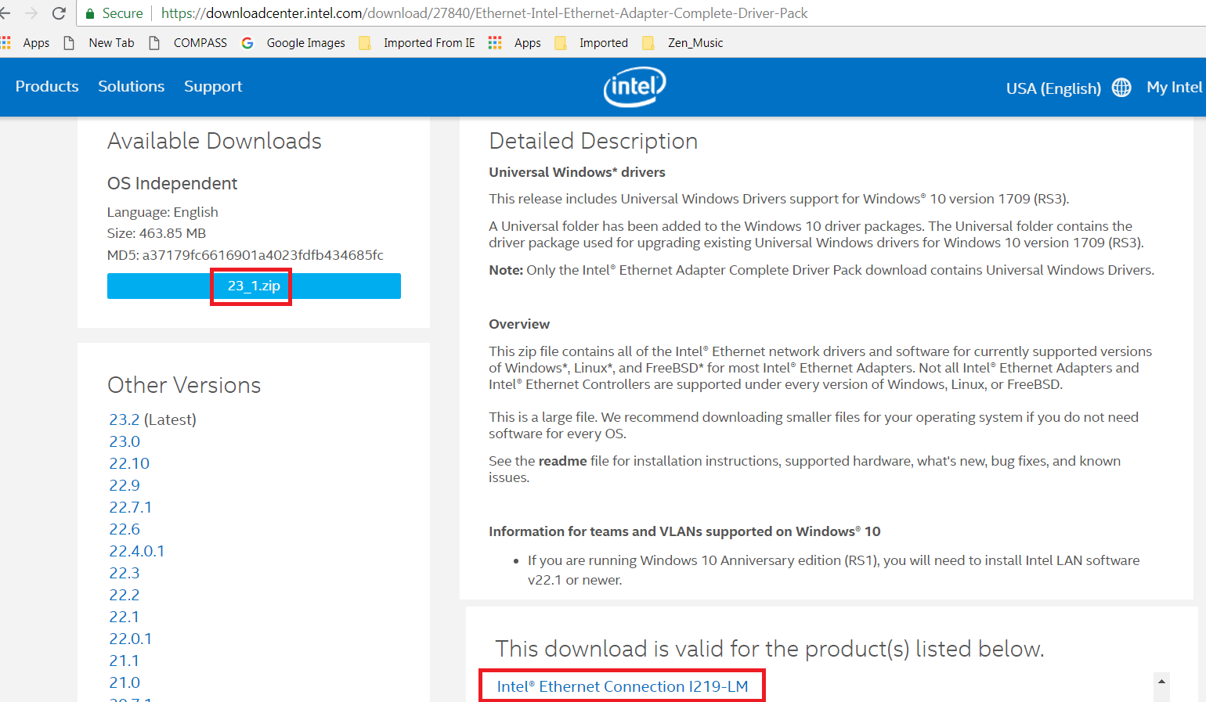

Figure 8: Intel Ethernet Adapter driver

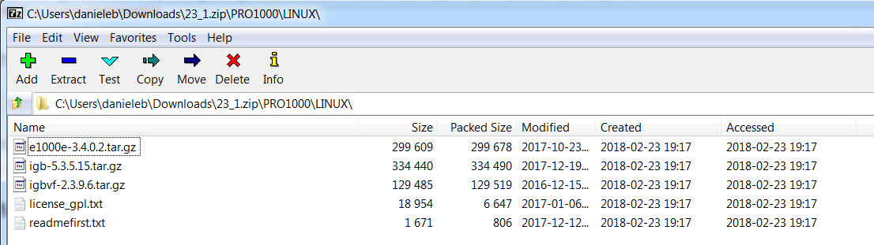

Figure 9: E1000 virtual network adapter for Intel 82545EM Gigabit Ethernet NIC

## **5.2 VGA default monitor**

Looking at the below website <https://askubuntu.com/questions/901326/how-to-start-a-fail-safe-graphics-session-with-mouse-web-browser>

I could bring up the GRUB menu after the BIOS had finished its loading by pressing the **SHIFT key**, and I selected the **advanced options** (see Figure 10)**, recovery mode** (see Figure 11)and from there the **Resume normal boot** (see Figure 12, after that I got an 800x600 SVGA resolution that enabled me to work decently with the Ubuntu desktop GUI.

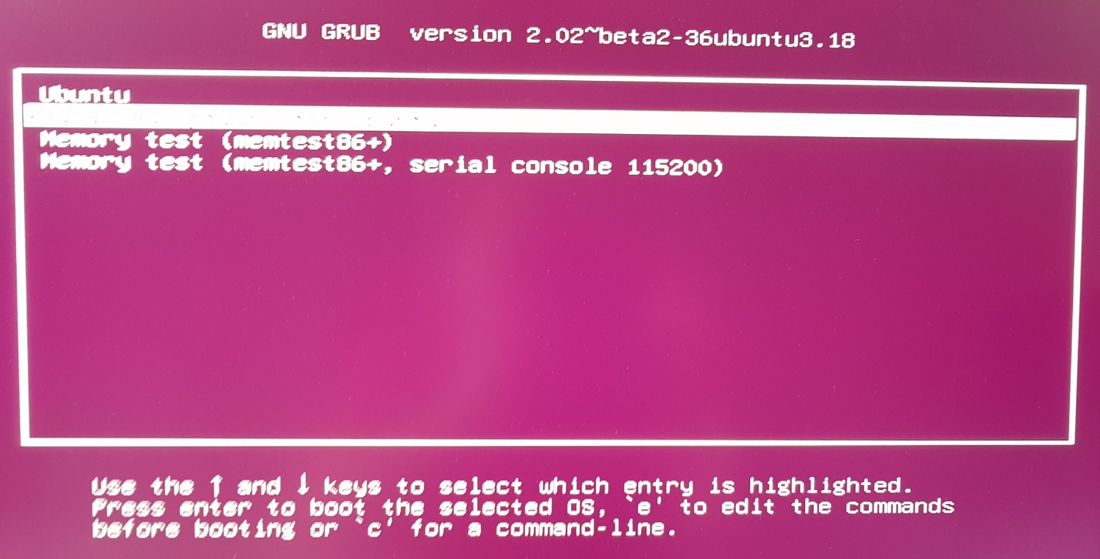

Figure 10: GRUB Ubuntu advanced options

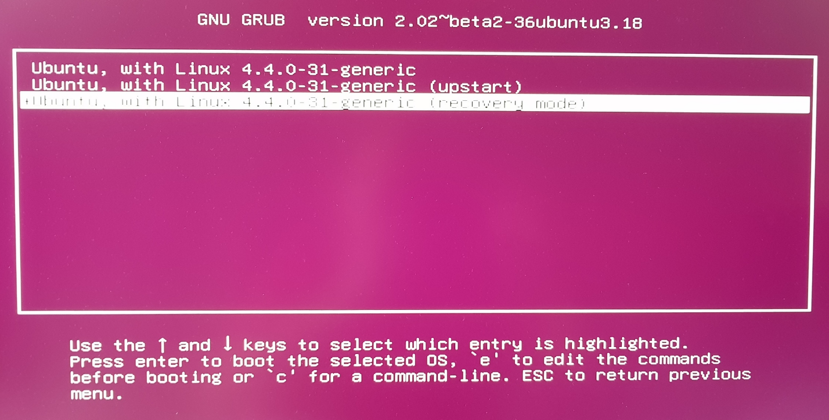

Figure 11: GRUB recovery mode

After having looked at the following pages:

* <https://askubuntu.com/questions/564049/desktop-bigger-than-screen>
* <http://ubuntuhandbook.org/index.php/2017/04/custom-screen-resolution-ubuntu-desktop/>

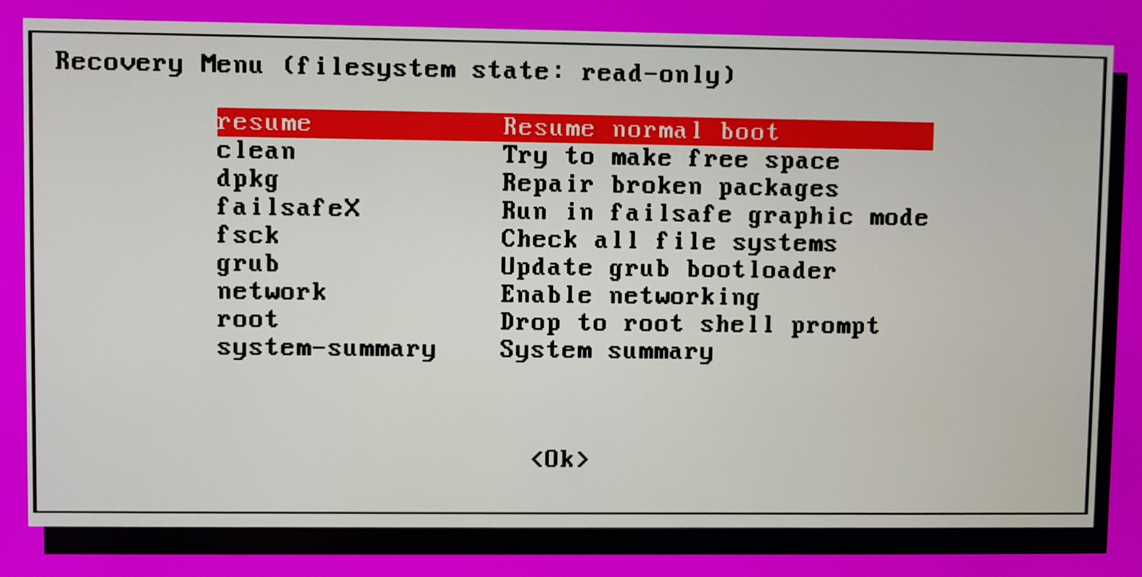

Figure 12: GRUB Resume normal boot

I tried the following commands:

**cvt 1600 900**

**sudo xrandr --newmode "1600x900_60.00" 118.25 1600 1696 1856 2112 900 903 908 934 -hsync +vsync**

**sudo xrandr --addmode default "1600x900_60.00"**

Eventually I was able to enlarge the resolution until 1024x768 XGA resolution, but no way to increase it up to HDTV 1920x1080. Also I was not able to make this configuration permanent: after every reboot VGA resolution was all what I got and I was forced any time to apply the Resume normal boot procedure. I decided to stop here, as the best is to install first the right driver of my NVIDIA Quadro P6000 graphic card.

## **5.3 Connect target ZCU102 board to Linux host PC with cables**

Setting up a serial communication between the Ubuntu Linux PC and the Zynq ZCU102 board was not that simple, even assuming <https://www.cyberciti.biz/faq/howto-setup-serial-console-on-debian-linux/>. I have done a lot of trials, here is the description of what worked fine in my case.

* Run the following Linux commands to understand which ports you have:
  + **dmesg**

[ 6449.745350] usb 4-1: USB disconnect, device number 3

[ 9751.915383] usb 3-2: new full-speed USB device number 2 using xhci_hcd

[ 9752.045153] usb 3-2: New USB device found, idVendor=10c4, idProduct=ea71

[ 9752.045160] usb 3-2: New USB device strings: Mfr=1, Product=2, SerialNumber=7

[ 9752.045164] usb 3-2: **Product: CP2108 Quad USB to UART Bridge Controller**

[ 9752.045167] usb 3-2: **Manufacturer: Silicon Labs**

[ 9752.045169] usb 3-2: SerialNumber: BA976282EC0D019911E60126C7C70E6

[ 9752.060869] usbcore: registered new interface driver usbserial

[ 9752.060908] usbcore: registered new interface driver usbserial_generic

[ 9752.060940] usbserial: USB Serial support registered for generic

[ 9752.065397] usbcore: registered new interface driver **cp210x**

[ 9752.065544] usbserial: USB Serial support registered for cp210x

[ 9752.066674] cp210x 3-2:1.0: cp210x converter detected

[ 9752.066817] usb 3-2: cp210x converter now attached to ttyUSB0

[ 9752.066860] cp210x 3-2:1.1: cp210x converter detected

[ 9752.067016] usb 3-2: cp210x converter now attached to ttyUSB1

[ 9752.067054] cp210x 3-2:1.2: cp210x converter detected

[ 9752.067207] usb 3-2: cp210x converter now attached to ttyUSB2

[ 9752.067243] cp210x 3-2:1.3: cp210x converter detected

[ 9752.067617] usb 3-2: cp210x converter now attached to ttyUSB3

[ 9759.167601] usb 3-1: new high-speed USB device number 3 using xhci_hcd

[ 9759.301175] usb 3-1: New USB device found, idVendor=0403, idProduct=6014

[ 9759.301183] usb 3-1: New USB device strings: Mfr=1, Product=2, SerialNumber=3

[ 9759.301186] usb 3-1: **Product: Digilent USB Device**

[ 9759.301189] usb 3-1: **Manufacturer: Digilent**

[ 9759.301192] usb 3-1: SerialNumber: 210308A127C5

[ 9752.060869] usbcore: registered new interface driver usbserial

[ 9752.060908] usbcore: registered new interface driver usbserial_generic

[ 9752.060940] usbserial: USB Serial support registered for generic

[ 9752.065397] usbcore: registered new interface driver cp210x

* + **dmesg | egrep –color ‘serial|tty$’**
  + **dmesg | egrep –color ‘serial|ttyUSB$[01234]’**
  + **dmesg | egrep –color ‘cp210x’**

[ 9752.065544] usbserial: USB Serial support registered for cp210x

[ 9752.066674] cp210x 3-2:1.0: cp210x converter detected

[ 9752.066817] **usb 3-2: cp210x converter now attached to ttyUSB0**

[ 9752.066860] cp210x 3-2:1.1: cp210x converter detected

[ 9752.067016] usb 3-2: cp210x converter now attached to ttyUSB1

[ 9752.067054] cp210x 3-2:1.2: cp210x converter detected

[ 9752.067207] usb 3-2: cp210x converter now attached to ttyUSB2

[ 9752.067243] cp210x 3-2:1.3: cp210x converter detected

[ 9752.067617] usb 3-2: cp210x converter now attached to ttyUSB3

* Install PuTTY with the command
  + **sudo apt-get install putty**
* Once the ZCU102 board is turned on and the two USB cables are connected to the PC, you can execute the following Linux command:
  + **sudo putty /dev/ttyUSB0 –serial –sercfg 115200,8,n,1,N**

If you want to set PuTTY via its GUI, you need to use **sudo** again

* Once PuTTY terminal pops up you have to configure the eth0 interface of the ZCU102 board:
  + **ifconfig eth0 192.168.1.101 netmask 255.255.255.0**
* You have to connect the target board and the host PC with an Ethernet cable and then set the eth1 host PC interface:
  + **sudo ifconfig eth1 192.168.1.100 netmask 255.255.255.0**
* to check the Ethernet wired communication between the host PC and target board, run the following commands as illustrated in Figure screenshot
  + ping 192.168.1.100 (from the target board, on the PuTTY terminal)
  + ping 192.168.1.101 (from host PC, on the Ubuntu terminal)

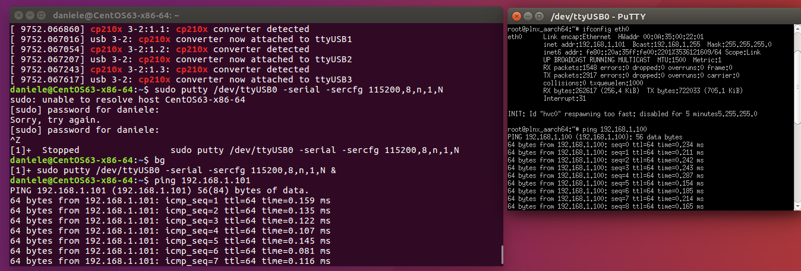

Figure: Ubuntu terminal running on the host (left side) and PuTTY terminal to serially talk with the target board (right side

# **6.0 Installing NVIDIA Quadro P6000 GPU driver**

First I downloaded the display driver of my Quadro P6000 GPU from here:

* <http://www.nvidia.com/download/driverResults.aspx/136120/en-us>
* <https://docs.nvidia.com/cuda/cuda-toolkit-release-notes/index.html>
* <https://developer.nvidia.com/cuda-toolkit-archive>

I then tried to install it in Ubuntu as root, but I stopped it because of a warning related to a mismatch between my GCC compiler release (older) and the one (newer) by which the kernel was compiled.

I decided to stop the above install and I went on with only the following commands.

1. Open a terminal session by hitting key **CTRL+ALT+F2**
2. Stop lightdm (the X-server) with the command: **sudo service lightdm stop**
3. Create a file at **/etc/modprobe.d/blacklist-nouveau.conf** with the following contents:
   * blacklist nouveau
   * blacklist lbm-nouveau
   * options nouveau modeset=0
   * alias nouveau off
   * alias lbm-nouveau off

Save the file and now execute the following command:

echo options nouveau modeset=0 | sudo tee -a /etc/modprobe.d/nouveau-kms.conf

1. **sudo update-initramfs -u**
2. **sudo add-apt-repository ppa:graphics-drivers**
3. **sudo apt-get update**
4. Now install and activate the latest drivers (for me it was version 390)

**sudo apt-get install nvidia-390**

1. Reboot your computer.

At the end I could see a desktop finally in 4K resolution, as my ACER 4K monitor.

# **Installing NVIDIA CUDA libraries**

## **7.1 CUDA-8.0 ToolKit**

1. Perform all the following install instructions:

* **sudo apt-get update**
* **sudo apt-get upgrade**
* **sudo apt-get install build-essential cmake git unzip pkg-config**
* **sudo apt-get install libjpeg-dev libtiff5-dev libjasper-dev**
* **sudo apt-get install libpng12-dev**
* **sudo apt-get install libavcodec-dev libavformat-dev libswscale-dev**
* **sudo apt-get install libv4l-dev**
* **sudo apt-get install libxvidcore-dev libx264-dev**
* **sudo apt-get install libgtk-3-dev**
* **sudo apt-get install libhdf5-serial-dev graphviz**
* **sudo apt-get install libopenblas-dev libatlas-base-dev gfortran**
* **sudo apt-get install python-tk python3-tk python-imaging-tk**
* **sudo apt-get install python2.7-dev python3-dev**
* **sudo apt-get install linux-image-generic linux-image-extra-virtual**
* **sudo apt-get install linux-source linux-headers-generic**

1. Before starting to install CUDA I read the material in the following 2 websites:

<https://github.com/bhavykhatri/Installing-_CUDA_toolkit_guide_LINUX/blob/master/README.md>

<http://docs.nvidia.com/cuda/cuda-installation-guide-linux/index.html#pre-installation-actions>

1. Install the **NVIDIA CUDA Toolkit 8.0** Feb 2017
2. you need to register first, in order to get then a login and password
3. surf here: <https://developer.nvidia.com/cuda-80-ga2-download-archive>
4. select **Linux**OS, **x86_64** Architecture, **Ubuntu** Distribution, **16.04** Version, **runfile (local)** Installer
5. you will get the installer (1.5GB) named

**cuda_8.0.61_375.26_linux.run**

1. you also need to download a patch named (97.5 MB)

**cuda_8.0.61.2_linux.run**

1. Stop the X-server by executing **sudo service lightdm stop**
2. Once download is finished, run the following commands (after changing to the directory where you have placed the file, typically ~/Download):
   * **chmod +x cuda_8.0.61_375.26_linux.run**
   * **chmod +x cuda_8.0.61.2_linux.run**
   * **mkdir installers**
   * **cd installers**
   * **sudo ../cuda_8.0.61.375.26_linux.run**
   * **sudo ../cuda_8.0.61.2_linux.run**
3. Note that in both cases (both the installer and the patch) you have to accept the NVIDIA EULA license and answer to the following questions:
   * Install the NVIDIA Accelerated Graphic Driver for Linux-x86_64 375.26 (up to you here: if you do it, remember that the X-server must be off)
   * Install OpenGL Libraries (NO)
   * Install the CUDA 8.0 Toolkit (YES)
   * Run nvidia-xconfig (YES)
   * Install the CUDA 8.0 Samples (YES)
   * set the CUDA Toolkit Install directory (accept default: /usr/local/cuda-8.0)
4. If you get an error, you have to look at the log file /var/log/nvidia-installer.log. In my case I missed the libraries libGLU.so libXmu.so, as illustrated in Figure 13; after a look at here <https://stackoverflow.com/questions/22360771/missing-recommended-library-libglu-so> I installed the missing libraries with the command

**apt-get install libglu1-mesa libxi-dev libxmu-dev libglu1-mesa-dev**

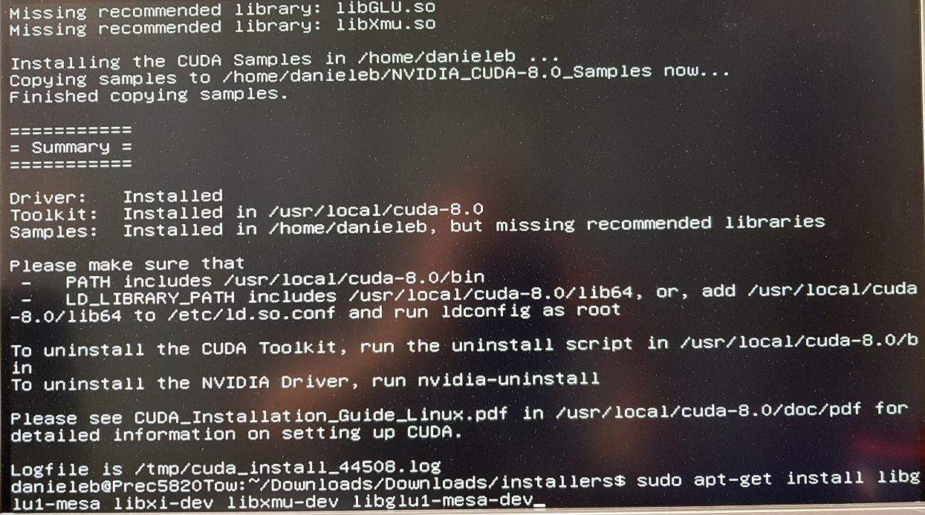

Figure 13: results of first trial to install CUDA 8.0

1. When things go well you should see something like the screenshot of Figure 14:

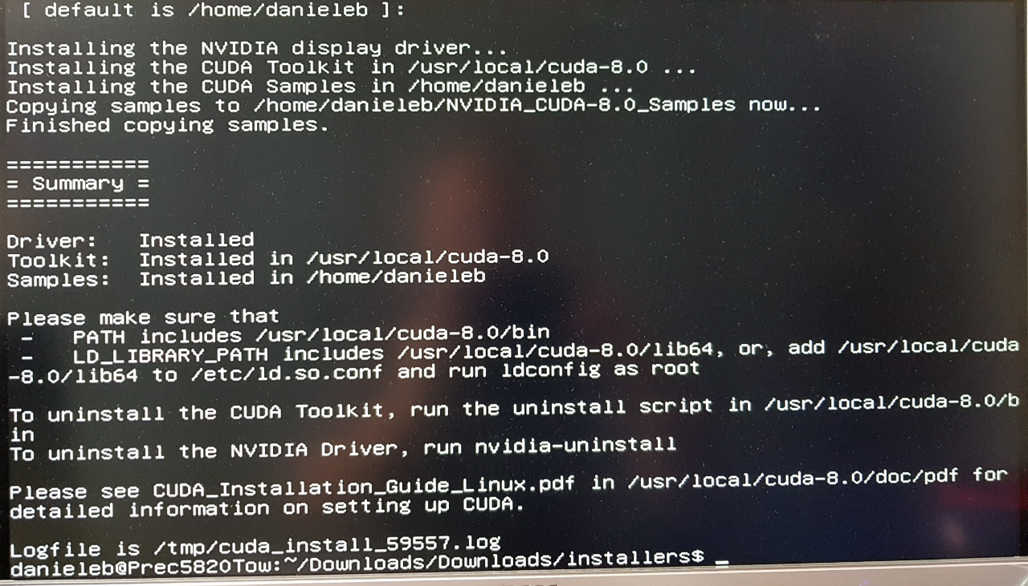

Figure 14: CUDA-8.0 correct install result

1. Add the NVIDIA loadable kernel module (KLM) to the Linux Kernel:
   * **sudo modprobe nvidia**
2. Add the following lines to **~/.bashrc** file
   1. # NVIDIA CUDA Toolkit
   2. export PATH=/usr/local/cuda-8.0/bin:$PATH
   3. export LD_LIBRARY_PATH=/usr/local/cuda-8.0/lib64/
3. Now execute test the CUDA Toolkit installation by compiling the deviceQuery  example program and running it:
   1. **source ~/.bashrc**
   2. **cd /usr/local/cuda-8.0/samples/1_Utilities/deviceQuery**
   3. **sudo make**
   4. **./deviceQuery**

In my case, unfortunately I got an error and I had to look at here:

<https://devtalk.nvidia.com/default/topic/760872/ubuntu-12-04-error-cudagetdevicecount-returned-30/>

but the situation become even worst: at any reboot the X-server was not restarting and I could only use the terminal (CTRL+ALT+F1). Therefore I decided to install the driver of Section **6.0 Installing NVIDIA Quadro P6000 GPU driver** with the command

**sudo ./NVIDIA-Linux-x86_64-390.77.run**

Again the installer was complaining of not having the right GCC release, but I answered YES to all questions and I installed it anyway. After the reboot I could finally see again my desktop in 4K resolution and I was able to run the commands of item 14 in the above list, now the output looks correct, as illustrated in Figure 15

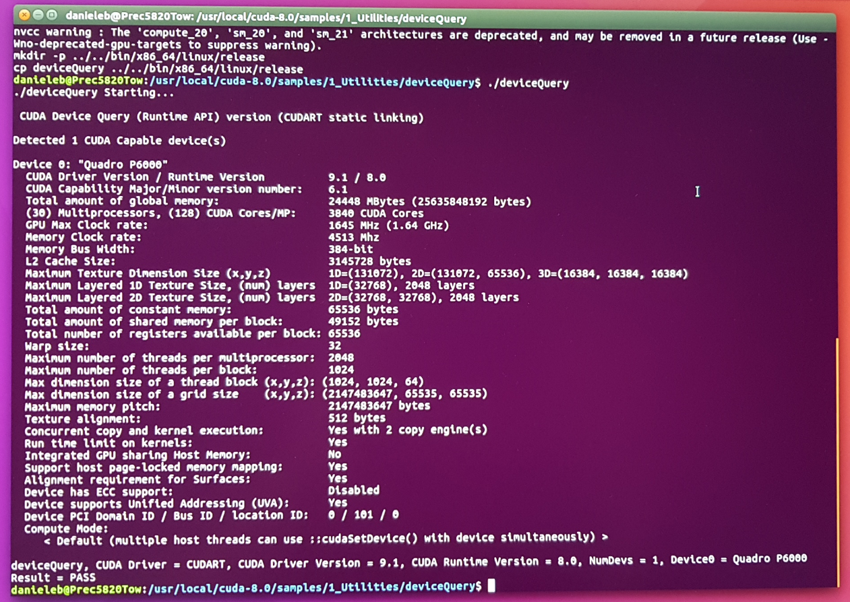

Figure 15: output of NVIDIA GPU Device Query

## **7.2 cuDNN 7.0.5**

Download **NVIDIA cuDNN v7.0.5** (you need to use your login and password) for Deep Learning (DL), from these various URLs, listed in order:

* <https://developer.nvidia.com/deep-learning-software> (click on DL Primitives **cuDNN**)
* <https://developer.nvidia.com/cudnn> (click on **Download** and then **Agree** on Licensing terms)
* <https://developer.nvidia.com/rdp/cudnn-download>
* select **Dowload cuDNN v7.0.5 (Dec 5, 2017) for CUDA 8.0**
* select [cuDNN v7.0.5 Library for Linux](https://developer.nvidia.com/compute/machine-learning/cudnn/secure/v6/prod/8.0_20170307/cudnn-8.0-linux-x64-v6.0-tgz)
* you will get the file (268 MB) named **cudnn-8.0-linux-x64-v7.tgz**
* put such file in the ~/Download/installers directory, then execute the following commands:

1. **cd ~/Download/installers**
2. **tar -zxf cudnn-8.0-linux-x64-v7.tgz**
3. **cd cuda**
4. **sudo cp -P ./lib64/* /usr/local/cuda-8.0/lib64/**
5. **sudo cp -P ./include/* /usr/local/cuda-8.0/include/**
6. **cd ~**

## **7.3 NCCL1**

**DeePhi’ DECENT compression tool requires libnccl.so.1 NVIDIA library which is no more supported, in favor of the most recent nccl 2.x.**

Due to that, I have saved its source code in a file called **nccl1.tar.gz**.

Put such file into your Download area and then launch the following commands (see below screenshot)

1. **cd ~/Download/**
2. **tar -zxf nccl1.tar.tgz**
3. **cd nccl-master**
4. **make CUDA_HOME=/usr/local/cuda test**

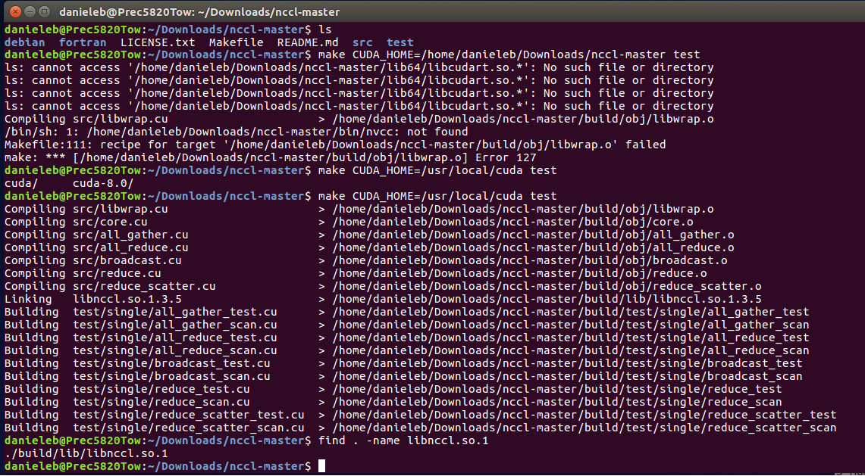

Figure: screenshot of how installing nccl1.0

then follow the instructions available on the **README.md** file, to finish test and finish the installation.

## **7.4 CUDA-9.1 ToolKit (optional)**

Instructions to alternatively install NVIDIA CUDA ToolKit 9.1 is the same as the 8.0, just go to the following pages:

* <https://developer.nvidia.com/cuda-toolkit-archive>
* <https://developer.nvidia.com/cuda-91-download-archive>
* <https://developer.nvidia.com/cuda-91-download-archive?target_os=Linux&target_arch=x86_64&target_distro=Ubuntu&target_version=1604&target_type=runfilelocal>

Alternatively to my instructions, you might want to use the following instructions (by Jon Cory), which I have not checked:

1. Install repository meta-data (as well as any patches)

**$** sudo dpkg -i cuda-repo-<distro>_<version>_<architecture>.deb

1. Installing the CUDA public GPG key

When installing using the local repo:

**$** sudo apt-key add /var/cuda-repo-<version>/7fa2af80.pub

os/<distro>/<architecture>/7fa2af80.pub

1. Update the Apt repository cache

**$** sudo apt-get update

1. Install CUDA

**$** sudo apt-get install cuda

1. The PATH variable needs to include /usr/local/cuda-9.1/bin with the command

**$** export PATH=/usr/local/cuda-9.1/bin${PATH:+:${PATH}}

In addition, when using the runfile installation method, the LD_LIBRARY_PATH variable needs to contain /usr/local/cuda-9.1/lib64 on a 64-bit system, or /usr/local/cuda-9.1/lib on a 32-bit system

1. To change the environment variables for 64-bit operating systems:

**$** export LD_LIBRARY_PATH=/usr/local/cuda-9.1/lib64\

${LD_LIBRARY_PATH:+:${LD_LIBRARY_PATH}}

## **7.5 cuDNN 7.0.5 for CUDA toolkit 9.1 (by J. Cory, also checked by me)**

Instructions are taken from here:

<http://docs.nvidia.com/deeplearning/sdk/cudnn-install/index.html>

In order to download cuDNN, ensure you are registered for the [NVIDIA Developer Program](https://developer.nvidia.com/accelerated-computing-developer).

1. Go to: [NVIDIA cuDNN home page](https://developer.nvidia.com/cudnn).
2. Click **Download**.
3. Complete the short survey and click **Submit**.
4. Accept the Terms and Conditions. A list of available download versions of cuDNN displays.
5. Select the cuDNN version you want to install (I used the Debian Packages). A list of available resources displays.
6. Navigate to your <cudnnpath> directory containing cuDNN Debian file.
7. Install the runtime library, for example:

sudo dpkg -i libcudnn7_7.0.3.11-1+cuda9.0_amd64.deb

1. Install the developer library, for example:

sudo dpkg -i libcudnn7-dev_7.0.3.11-1+cuda9.0_amd64.deb

1. Install the code samples and the cuDNN Library User Guide, for example:

sudo dpkg -i libcudnn7-doc_7.0.3.11-1+cuda9.0_amd64.deb

1. Copy the cuDNN sample to a writable path.

$cp -r /usr/src/cudnn_samples_v7/ $HOME

1. Go to the writable path.

$ cd $HOME/cudnn_samples_v7/mnistCUDNN

1. Compile the mnistCUDNN sample.

$make clean && make

1. Run the mnistCUDNN sample.

$ ./mnistCUDNN

If cuDNN is properly installed and running on your Linux system, you will see a message similar to the following:

Test passed!

# **Create your Python2.7 Virtual Env. with ML-related packages**

Whatever here described is also valid in general for Python3.5, with really few differences.

* Perform all the following install instructions:
  + wget <https://bootstrap.pypa.io/get-pip.py>
  + sudo python get-pip.py
  + sudo python3 get-pip.py
  + sudo pip2 install virtualenv virtualenvwrapper
  + sudo rm -rf ~/.cache/pip get-pip.py
* Add the following lines to the **~/.bashrc** file
  + # virtualenv and virtualenvwrapper
  + export WORKON_HOME=$HOME/.virtualenvs
  + export VIRTUALENVWRAPPER_PYTHON=/usr/bin/python2
  + source /usr/local/bin/virtualenvwrapper.sh

In case of Python3 the third line would obviously be:

* export VIRTUALENVWRAPPER_PYTHON=/usr/bin/python3
* Now reload the changes by running:
  + source ~/.bashrc

WARNING: DO NOT MIX UP ENVIRONMENTS WITH PYTHON 2 or 3.

Always “**source ~/.bashrc**” with the right python version you want to use (for example Python2) by commenting the lines related to the other python version not used (for example Python3), otherwise you will have many errors.

* From now until the end of this document I will use only Python2.7 (shortly Python2), as most of the Caffe tutorials on Internet use Python2.7, note that the commands are basically the same for both Python 2.7 and 3.5 releases**.**
* Create a Python2, based virtual environment, for example “caffe_py27”:
  + mkvirtualenv caffe_py27 –p python2
  + workon caffe_py27

In case of python3 the first line would be

* mkvirtualenv caffe_py35 –p python3
* Import all the following ML related packages (which I have already checked to work fine in my Ubuntu 16.04 LapTop PC and saved with the command **pip2 freeze > filename.txt**) by running the command (note that you must be inside the virtualenv)
* **pip2 install –r ~/scripts/caffe_py27_requirements.txt**

## **8.1 Content of caffe_py27_requirements.txt file**

absl-py==0.1.13

astor==0.6.2

backports.functools-lru-cache==1.5

backports.shutil-get-terminal-size==1.0.0

backports.weakref==1.0.post1

bleach==1.5.0

certifi==2018.1.18

chardet==3.0.4

cloudpickle==0.5.3

cycler==0.10.0

Cython==0.28.4

dask==0.18.2

decorator==4.3.0

enum34==1.1.6

funcsigs==1.0.2

futures==3.2.0

gast==0.2.0

graphviz==0.8.4

grpcio==1.10.1

h5py==2.8.0

html5lib==0.9999999

idna==2.6

imutils==0.4.6

ipython==5.7.0

ipython-genutils==0.2.0

Keras==2.1.5

kiwisolver==1.0.1

leveldb==0.194

lmdb==0.94

Markdown==2.6.11

matplotlib==2.2.2

mock==2.0.0

networkx==2.1

nose==1.3.7

numpy==1.15.0

olefile==0.44

pandas==0.23.3

pathlib2==2.3.2

pbr==4.2.0

pexpect==4.6.0

pickleshare==0.7.4

Pillow==5.2.0

progressbar2==3.37.0

prompt-toolkit==1.0.15

protobuf==3.6.0

ptyprocess==0.6.0

pydot==1.2.4

Pygments==2.2.0

pyparsing==2.2.0

python-dateutil==2.7.3

python-gflags==3.1.2

python-utils==2.3.0

pytz==2018.5

PyWavelets==0.5.2

PyYAML==3.13

requests==2.18.4

scandir==1.7

scikit-image==0.14.0

scikit-learn==0.19.1

scipy==1.0.0

simplegeneric==0.8.1

six==1.11.0

stevedore==1.29.0

subprocess32==3.5.2

tensorboard==1.7.0

tensorflow-gpu==1.4.1

tensorflow-tensorboard==0.4.0

termcolor==1.1.0

toolz==0.9.0

traitlets==4.3.2

urllib3==1.22

virtualenv==16.0.0

virtualenv-clone==0.3.0

virtualenvwrapper==4.8.2

wcwidth==0.1.7

Werkzeug==0.14.1

## **8.2 Install other packages needed by Caffe, included openCV 2.4**

**Follow the next instructions out of any python virtualenv:**

* sudo apt-get update
* sudo apt-get upgrade
* sudo apt-get install -y libleveldb-dev libsnappy-dev protobuf-compiler
* sudo apt-get install -y --no-install-recommends libboost-all-dev
* sudo apt-get install -y libgflags-dev libgoogle-glog-dev liblmdb-dev
* sudo apt-get install -y python-pip
* sudo apt-get install -y python-numpy python-scipy
* sudo apt-get install -y python-opencv
* sudo apt-get install -y python-lmdb

Note that the below packages should be already installed from previous Sections

* sudo apt-get install -y build-essential cmake git pkg-config
* sudo apt-get install -y libprotobuf-dev libhdf5-serial-dev
* sudo apt-get install -y libatlas-base-dev
* sudo apt-get install -y python-dev

For OpenCV 2.4 you only need to run the below command:

* sudo apt-get install -y libopencv-dev

Note that the cv2 package was installed in **/usr/lib/python2.7/dist-packages** instead of **/usr/local/lib/python2.7/dist-packages**, therefore I applied the following workaround:

* cd ~/.virtualenvs/caffe_py27/local/lib/python2.7/site-packages/
* ln -s /usr/lib/python2.7/dist-packages/cv2.x86_64-linux-gnu.so cv2.so
* cd ~

Now test your OpenCV install, whatever python you are using

* + python
  + import cv2
  + cv2.__version__
  + **cv2.__file__**
  + quit()

In case cv2 would not be import (for python2 for example), just add the following 2 lines just before the “import cv2”:

* + python
  + **import sys**
  + **sys.path.append(“/usr/local/lib/python2.7/site-packages”)**
  + import cv2
  + cv2.__version__
  + quit()

Test your TensorFlow install:

* + python
  + import tensorflow
  + tensorflow.__version__
  + quit()

If you have errors after <import panda> you might need to re-install panda with the following command (at this point it is better you also re-install tensorflow):

* + sudo pip2 install pandas

Test your Keras install:

* + python
  + import keras
  + keras.__version__
  + quit()

Alternatively, in case you want to use OpenCV 3.x, you also need to install all the below packages (again, some of them are redundant as already installed previously):

* sudo apt-get install --assume-yes build-essential cmake git
* sudo apt-get install --assume-yes pkg-config unzip ffmpeg qtbase5-dev python-dev python3-dev python-numpy python3-numpy
* sudo apt-get install --assume-yes libopencv-dev libgtk-3-dev libdc1394-22 libdc1394-22-dev libjpeg-dev libpng12-dev libtiff5-dev libjasper-dev
* sudo apt-get install --assume-yes libavcodec-dev libavformat-dev libswscale-dev libxine2-dev libgstreamer0.10-dev libgstreamer-plugins-base0.10-dev
* sudo apt-get install --assume-yes libv4l-dev libtbb-dev libfaac-dev libmp3lame-dev libopencore-amrnb-dev libopencore-amrwb-dev libtheora-dev
* sudo apt-get install --assume-yes libvorbis-dev libxvidcore-dev v4l-utils python-vtk
* sudo apt-get install --assume-yes liblapacke-dev libopenblas-dev checkinstall
* sudo apt-get install --assume-yes libgdal-dev

## **8.3 How to install openCV 3.3 from scratch (optional)**

If you want to install OpenCV 3.3 instead of 2.4 look at here.

1. Compile and install OpenCV 3.3 (also 3.2 or 3.1 are fine) without CUDA support (simply to avoid many compilation errors due to CUDA, all in all I want the DL stuff to be CUDA accelerated, not the OpenCV stuff)
   * cd ~
   * wget -O opencv.zip https://github.com/Itseez/opencv/archive/3.3.0.zip
   * wget -O opencv_contrib.zip <https://github.com/Itseez/opencv_contrib/archive/3.3.0.zip>
   * mkdir opencv
   * mv opencv_contrib.zip opencv.zip ./opencv
   * cd opencv
   * unzip opencv.zip
   * unzip opencv_contrib.zip
   * cd ./opencv-3.3.0/
   * mkdir build
   * cd build
   * cmake -D CMAKE_BUILD_TYPE=RELEASE \
   * -D CMAKE_INSTALL_PREFIX=/usr/local \
   * -D WITH_CUDA=OFF \
   * -D INSTALL_PYTHON_EXAMPLES=ON \
   * -D OPENCV_EXTRA_MODULES_PATH=~/opencv_contrib-3.3.0/modules \
   * -D BUILD_EXAMPLES=ON ..
2. in case of errors you might need to add also the following flags (before any cmake trial, create a completely new empty build directory) to the previous ones:
   * –D PYTHON_EXECUTABLE=~/.virtualenvs/cudadnn/bin/python \
   * –D ENABLE_PRECOMPILED_HEADERS=OFF \
   * –D CUDA_GENERATION=AUTO \
3. Now compile OpenCV
   * make –j4
   * sudo make install
   * sudo /bin/bash -c 'echo "/usr/local/lib" > /etc/ld.so.conf.d/opencv.conf'
   * sudo ldconfig
   * sudo apt-get update
   * sudo apt-get install checkinstall
   * sudo checkinstall
   * cd ~
4. Reboot your machine. You are now ready to install Caffe with OpenCV3.x

## **8.4 File install_caffe*.sh**

I have captured all the **sudo apt-get install** commands of SubSections 7.1 and 8.2 in a file to be executed with the command **source install_caffe*.sh**

See below its content:

sudo apt-get update

sudo apt-get upgrade

sudo apt-get install build-essential cmake git unzip pkg-config

sudo apt-get install libjpeg-dev libtiff5-dev libjasper-dev libpng12-dev

sudo apt-get install libavcodec-dev libavformat-dev libswscale-dev libv4l-dev

sudo apt-get install libxvidcore-dev libx624-dev

sudo apt-get install libxvidcore-dev libx264-dev

sudo apt-get install libgtk-3-dev

sudo apt-get install libhdf5-serial-dev graphviz

sudo apt-get install libopenblas-dev libatlas-base-dev gfortran

sudo apt-get install python2.7-dev python3-dev

sudo apt-get install linux-image-generic linux-image-extra-virtual

sudo apt-get install linux-source linux-headers-generic

sudo apt-get install libglu1-mesa libxi-dev libxmu-dev libglu1-mesa-dev

sudo apt-get install --no-install-recommends libboost-all-dev

sudo apt-get install -y build-essential

sudo apt-get install -y cmake

sudo apt-get install -y git

sudo apt-get install -y pkg-config

sudo apt-get install -y libprotobuf-dev

sudo apt-get install -y libleveldb-dev

sudo apt-get install -y libsnappy-dev

sudo apt-get install -y libhdf5-serial-dev

sudo apt-get install -y protobuf-compiler

sudo apt-get install -y libatlas-base-dev

sudo apt-get install -y libgflags-dev

sudo apt-get install -y libgoogle-glog-dev

sudo apt-get install -y liblmdb-dev

sudo apt-get install python-pip

sudo apt-get install python-dev

sudo apt-get install python-numpy

sudo apt-get install python-scipy

sudo apt-get install python-opencv

sudo apt-get install python-lmdb

sudo apt-get install libopencv-dev

# **Install Caffe-SSD-Ristretto**

First of all you need to donwload the code. You have 2 choices:

* **Ristretto** is public available here: <https://github.com/pmgysel/caffe>.

It was developed by GL-Research. There is a WiKi page associated to it

<https://gl-research.com/caffe/ristretto/wikis/home>

and you need to contact the owner to get access to it (Javier Garcia, email address: [jgarcia@gl-research.com](mailto:jgarcia@gl-research.com)).

* **Caffe-SSD-Ristretto** is Xilinx internal available here:

<https://gitenterprise.xilinx.com/smenon/Caffe-SSD-Ristretto>

They both contain the original Caffe BVLC 1.0 plus other additions. In particular, Caffe-SSD-Ristretto contains also Ristretto and some changes to Caffe BVLC 1.0 suitable to manage the SSD Object Detection. Installing the first or the second is the same procedure (I have both of them in my laptop), therefore I will describe only the Caffe-SSD-Ristretto, being it more general.

Put in your ~/.bashrc file the following line, by adjusting the pathname where you files stay

**export CAFFE_ROOT=/home/danieleb/caffe_tools/Caffe-SSD-Ristretto**

1. workon caffe_py27
2. cd $CAFFE_ROOT
3. cp Makefile.config.example Makefile.config
4. Now edit **Makefile.config** before running any other step.

* Uncomment the CPU_ONLY:=1 line at the top, if you don't have a GPU. On the contrary, if you have a GPU, leave it commented and uncomment USE_CUDNN:=1
* USE_OPENCV:=1, to enable OpenCV.
* Remove the following 2 lines

-gencode arch=compute_20,code=sm_20 \

-gencode arch=compute_20,code=sm_21 \

* Check your PYTHON_INCLUDE to be similar to this (add the third line only if your python2.7 previous installation generated files in both /usr/lib and /usr/local/lib, otherwise leave it commented)

PYTHON_INCLUDE := /usr/include/python2.7 \

/usr/lib/python2.7/dist-packages/numpy/core/include

/usr/local/lib/python2.7/dist-packages/numpy/core/include

* Add the following two lines to **Makefile.config**  (make sure each line stays in a single line, without any carriage return), otherwise you will get a compilation error during the step of **make all**
* INCLUDE_DIRS:=$(PYTHON_INCLUDE) /usr/local/include /usr/include/hdf5/serial
* LIBRARY_DIRS:=$(PYTHON_LIB) /usr/local/lib /usr/lib

/usr/lib/x86_64-linux-gnu /usr/lib/x86_64-linux-gnu/hdf5/serial /usr/local/share/OpenCV/3rdparty/lib

1. Now you should edit also the **Makefile**, to avoid possible future compilation errors that otherwise could compare. You can first do a trial without modifying it and then, if you got errors, try the below changes:

* Replace the following line

NVCCFLAGS+= -ccbin=$(CXX) -Xcompiler -fPIC $(COMMON_FLAGS)

with the following line (everything on the same line, no carriage-return)

NVCCFLAGS+=-D_FORCE_INLINES -ccbin=$(CXX) -Xcompiler -fPIC $(COMMON_FLAGS)

* if you are using OpenCV 3.x and not OpenCV2, you also need to add to the following LIBRARIES

opencv_imgcodecs opencv_videoio

* Now open the file **CMakeLists.txt** and add the following two lines:

# ---[ Includes

set(${CMAKE_CXX_FLAGS} "-D_FORCE_INLINES ${CMAKE_CXX_FLAGS}")

1. Now you can run the following commands to build and test Caffe-SSD-Ristretto (note that 8 is the amount of parallel CPUs of your PC, if you have less you need to use a small number):

* cd /usr/lib/x86_64-linux-gnu
* sudo ln -s libhdf5_serial.so.10.0.2 libhdf5.so
* sudo ln -s libhdf5_serial_hl.so.10.0.2 libhdf5_hl.so
* cd $CAFFE_ROOT
* make clean
* make all –j 8
* make test –j 8
* make runtest –j 8
* make pycaffe
* make distribute

1. Finally execute the following commands (or put them into your **~/.bashrc** Linux file)

* export LD_LIBRARY_PATH=$CAFFE_ROOT/distribute/lib:$LD_LIBRARY_PATH
* export PYTHONPATH=$CAFFE_ROOT/distribute/python:$PYTHONPATH

## **9.1 Script to activate the virtual environment**

My solution to have parallel different virtual environments in a clean way is based on a proper **.bashrc** file and a shell script (in **/home/danieleb/scripts**), each one for a specific virtualenv.

In this case I have the **activate_caffe-ssd-ristretto_py27.sh** using **.bashrc** to be launched every time you want to enter in this virtualenv (similarly t what done in AWS by Amazon) with the command

**source activate_caffe-ssd-ristretto_py27**.

Here is the content of the list lines I added to the original **.bashrc**

# MACHINE LEARNING: reset variables

LD_LIBRARY_PATH=$(getconf LD_LIBRARY_PATH)

PYTHONPATH=$(getconf PYTHONPATH)

CAFFE_ROOT=$(getconf CAFFE_ROOT)

#NVIDIA CUDA 8.0 Toolkit

export PATH=/usr/local/cuda-8.0/bin:$PATH

export LD_LIBRARY_PATH=/usr/local/cuda-8.0/lib64/:$LD_LIBRARY_PATH

and here is the content of **activate_caffe-ssd-ristretto_py27.sh**

echo ""

echo "VIRTUALENV WITH Caffe-SSD-Ristretto, PYTHON2.7, CUDA-8.0 cuDNN-7.0.5, TENSORFLOW-GPU 1.4.1"

echo ""

source ~/.bashrc

# caffe related variables

export CAFFE_ROOT=/home/danieleb/caffe_tools/Caffe-SSD-Ristretto

export LD_LIBRARY_PATH=$CAFFE_ROOT/distribute/lib

export PYTHONPATH=$CAFFE_ROOT/distribute/python

# virtualenv for python2.7

export WORKON_HOME=$HOME/.virtualenvs

export VIRTUALENVWRAPPER_PYTHON=/usr/bin/python

export VIRTUALENVWRAPPER_VIRTUALENV=/usr/local/bin/virtualenv

source /usr/local/bin/virtualenvwrapper.sh

export PYTHONPATH=/usr/local/lib/python2.7/dist-packages:$PYTHONPATH

workon caffe_py27

## **9.2 Install Ristretto**

Once you have installed **Caffe-SSD-Ristretto**, installing either **Ristretto** standalone is really simple. In theory you would not need it, but its Python scripts can be different and you might need to use them sooner or later. The shortest way is to create a new virtualenv from python2.7, named **ristretto_py27**.

Focusing only on **Ristretto** now, assuming the root directory will be called Ristretto, from there you can copy the Makefile.config, Makefile and CMakeLists.txt files from Caffe-SSD-Ristretto then just launch the usual commands to install Ristretto:

* cd Ristretto
* make clean
* make all –j 8
* make test –j 8
* make runtest –j 8
* make pycaffe
* make distribute

Create a new shell file **activate_ristretto.sh**

echo ""

echo "VIRTUALENV WITH Ristretto, PYTHON2.7, CUDA-8.0 cuDNN-7.0.5, TENSORFLOW-GPU 1.4.1"

echo ""

source ~/.bashrc

# MACHINE LEARNING

export CAFFE_ROOT=/home/danieleb/caffe_tools/Ristretto

export LD_LIBRARY_PATH=$CAFFE_ROOT/distribute/lib

export PYTHONPATH=$CAFFE_ROOT/distribute/python

# virtualenv for python2.7

export WORKON_HOME=$HOME/.virtualenvs

export VIRTUALENVWRAPPER_PYTHON=/usr/bin/python

export VIRTUALENVWRAPPER_VIRTUALENV=/usr/local/bin/virtualenv

source /usr/local/bin/virtualenvwrapper.sh

export PYTHONPATH=/usr/local/lib/python2.7/dist-packages:$PYTHONPATH

workon ristretto_py27

## **9.3 Possible build errors**

1. See the compilation problem I had on the file **cudnn.hpp** which I had to correct as illustrated in Figure 16, based on <https://github.com/MhLiao/TextBoxes_plusplus/pull/6/files?diff=split>
2. If you used Python3 instead of Python2 you will probably have a linker error about a missing library named **libboost_python3.so** after the first **make all** trial. If you look at the directory

* ls –l /usr/lib/x86_64-linux-gnu/libboost_python*

you will find something like libboost_python-py35.so.1.58.0

therefore, create a softlink with the commands

* cd /usr/lib/x86_64-linux-gnu
* ln –s libboost_python-py35.so.1.58.0 libboost_python3.so

1. If you get an error during the make runtest –j8, about “**LRN layer only supports minifloat**” therefore you need to add the following lines before line 46 of file

src/caffe/test/test_layer_factory.cpp

if (iter->first ==”LRNRistretto”) {

layer_param.mutable_quantization_param()->set_precision(

caffe::QuatizationParameter_Precision_MINIFLOAT):

}

1. If you compiled with GPU (USE_CUDNN:= 1, in Makefile.config) you might need to modify line 112 of file include/caffe/util/cudnn.hpp

by replacing

cudnnSetConvolution2Descriptor(*conv,

with

cudnnSetConvolution2Descriptor_v4(*conv,

Note that you just added “_v4” to the function name.

*Note that I am not sure anymore about this point. It happened to me in the first Ristretto install on my LapTop but never happened now with the Dell 5820 Desktop*

1. Due to some runtime errors in the test of some python scripts I had to launch the two following commands to solve them, from caffe_py27 virtual environment launch:

* pip2 install lmdb
* sudo apt-get install python-tk

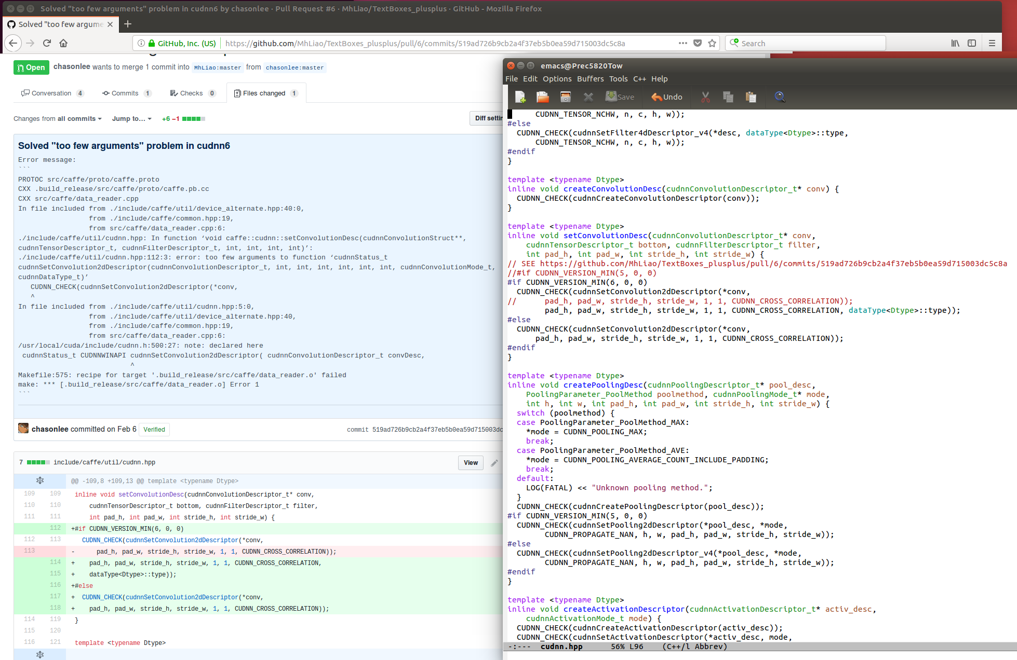

Figure 16: solving a compilation problem due to **cudnn.hpp**

# **Shortcut for last two sections**

Running all the instructions of Sections 8 and 9 can be really painful. In an attempt to make your life easier I have developed a shortcut solution that should hopefully execute everything automatically for you.

The archive **install_caffe_scripts.tar** contains everything you need: Makefiles, .bashrc and activation shell scripts. By launching those scripts everything should be automatically installed, provided you did not fail in installing NVIDIA GPU driver and CUDA 8.0 libraries as explained in Sections 6 and 7.

You need to have your PC connected to Internet as we will clone caffe from the github repositories.

First save the **install_caffe_scripts.tar** in your home directory (represented by the tilde **”~”** symbol in Linux).

Now, execute the following Linux commands to install Ristretto:

* cd ~
* tar –xvf install_caffe_scripts.tar
* mkdir ~/caffe_tools
* source ~/scripts/caffe/install_ristretto_caffe.sh

# **Install DeePhi’ tools**

DeePhi’ tools for ML implementation on Xilinx FPGA -called DNNDK- are split in two parts, one running on the Ubuntu 16.04 PC (the Host) and another running on the ZCU102 board (the Target). They are all placed in the same compressed archive (typically of 6GB size). The user has to unzip such archive and then build the image file to boot the Target ZCU102 board, which has to be connected via WLAN to the Host PC (see Section 5.3). Once the board has booted, via ssh/scp commands part of the tools are moved on the Host, while the remaining stay on the Target. Be sure the jumpers of ZCU102 are set as illustrated in Figure 18 (see also <https://www.xilinx.com/support/answers/69164.html>).

The Host PC side of the toolchain has to be compatible with:

* + ubuntu 16.04 + cuda 8.0 + cuDNN v7.0.5
  + ubuntu 16.04 + cuda 9.0 + cuDNN v7.0.5
  + ubuntu 16.04 + cuda 9.1 + cuDNN v7.0.5
  + libnccl.so.1 (follow the instructions from Section 7.3)

In my case I have selected cuda 8.0 because I can have both TensorFlow and Caffe in the same virtual environment. If you arrived at this page of this document means that you have already installed successfully cuda, so you do not need to do anything more.

Note that Caffe’ 1.0 installed from the github branch master is not required as DNNDK already has an internal version of Caffe, specifically the fork NVIDIA-Caffe.

Download DeePhi tools and ZCU102 image files from the DeePhi website. In particular:

* **deephi_dnndk_v2.08_beta.tar.gz** from <http://deephi.com/assets/deephi_dnndk_v2.08_beta.tar.gz>
* **2018-12-04-ZCU102-desktop-stretch.img.zip** from

<http://www.deephi.com/assets/2018-12-04-zcu102-desktop-stretch.img.zip>

Now you have to execute the following steps.

* On your Host PC open the **deephi_dnndk_v2.08_beta.tar.gz** file (assuming you have put it in ~/DNNDK) with the following commands and prepare the files to be sent to the Target board later
  + **cd ~/DNNDK**
  + **gzip –v –d deephi_dnndk_v2.08_beta.tar.gz**
  + **tar –xvf deephi_dnndk_v2.08_beta.tar**
  + **cd deephi_dnndk_v2.08_beta**
  + **tar –cvf common.tar ./common**
  + **tar –cvf ZCU102.tar ./ZCU102**
  + **gzip ZCU102.tar**

**ZCU102.tar.gz** and **common.tar** are the files you need to transfer from the Host PC to the Target board. But before doing it you have to prepare the sd card.

* Unzip **2018-12-04-ZCU102-desktop-stretch.img.zip** to get the image file **2018-12-04-ZCU102-desktop-stretch.img**. Insert an empty SD-Card (with size >= 16 GB) into your Host Ubuntu Linux PC
* Execute the command

**sudo lsblk**

on the Linux PC and search for your ZCU102 SD-Card (in some Ubuntu PCs the sd-card is seen as **/dev/ssd** in others as **/dev/mmcblk0**); let us assume it is called **/dev/sdd**

* Burn the img file on the SD-Card with the Linux command:

**sudo dd if=deephi_zcu102_dnndk_1.08.img of=/dev/ssd**

(in case of troubles look at [**https://learn.sparkfun.com/tutorials/sd-cards-and-writing-images**](https://learn.sparkfun.com/tutorials/sd-cards-and-writing-images)**)**

* Normally it takes about 10-30 min depending on your PC
* Once the above process has finished, you can boot the Target board
* Open a puTTY terminal (if requested, login/password: root/root) with the usual Zynq parameters (115200,8,n,1,N) for the UART connection. Note that you have to be superuser, therefore call the PuTTY GUI with **sudo** or call it via the following command line:

**sudo putty /dev/ttyUSB0 –serial –sercfg 115200,8,n,1,N**

* Connect a WLAN cable from Target board to the Host PC, then run the following commands:
* (from Target) **ifconfig eth0 192.168.1.100 netmask 255.255.255.0**
* (from Host) **sudo ifconfig eth1 192.168.1.101 netmask 255.255.255.0**
* (from Host)

**cd ~/DNNDK/deephi_dnndk_v2.08_beta**

**scp common.tar root@192.168.1.100:/root**

**scp ZCU102.tar.gz root@192.168.1.100:/root**

* (from Host)

**cd ~/DNNDK/deephi_dnndk_v2.08_beta**

**cd host_x86**

**sudo ./install.sh ZCU102**

* (from Target)

**cd /root**

**gzip –v –d *.gz**

**tar –xvf common.tar**

**tar –xvf ZCU102.tar**

**cd ZCU102**

**./install.sh**

Once finished you should see something similar to what shown in Figure 19 and Figure 20.

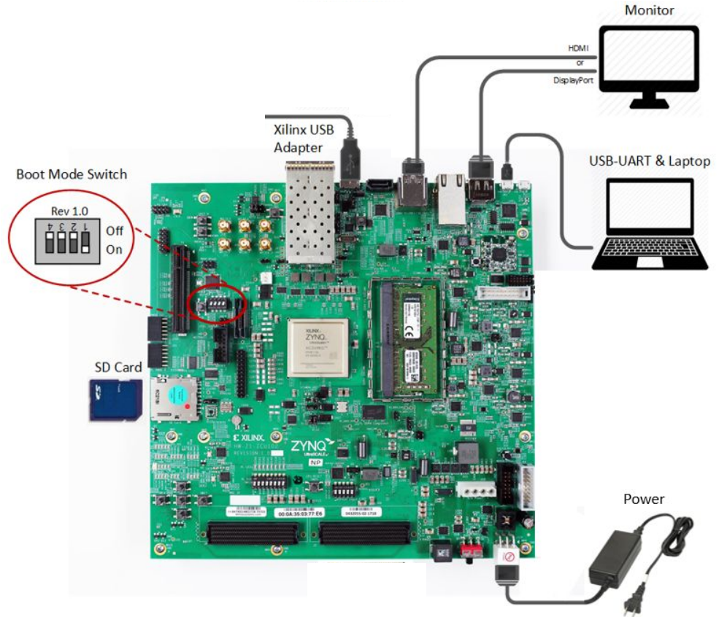

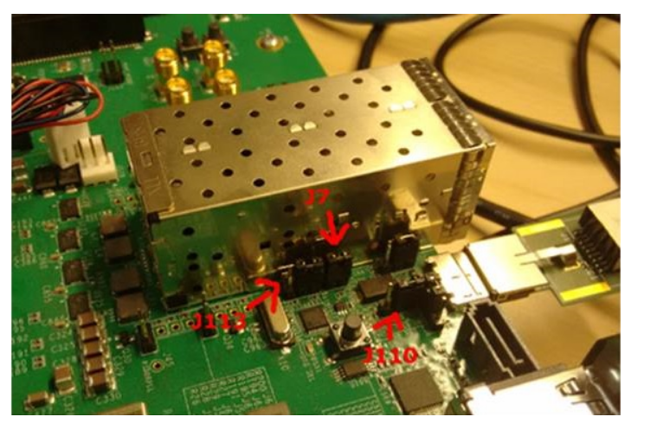Figure : ZCU102 board setup for SD-Card booting

Figure 17

Figure 18: ZCU102 setup of the jumpers J7, J113 and J110

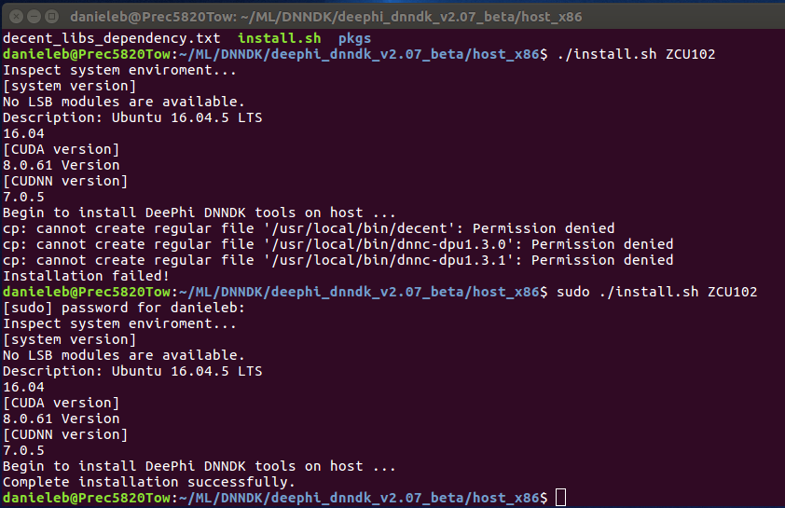

Figure 19: DeePhi DNNDK install on Host PC

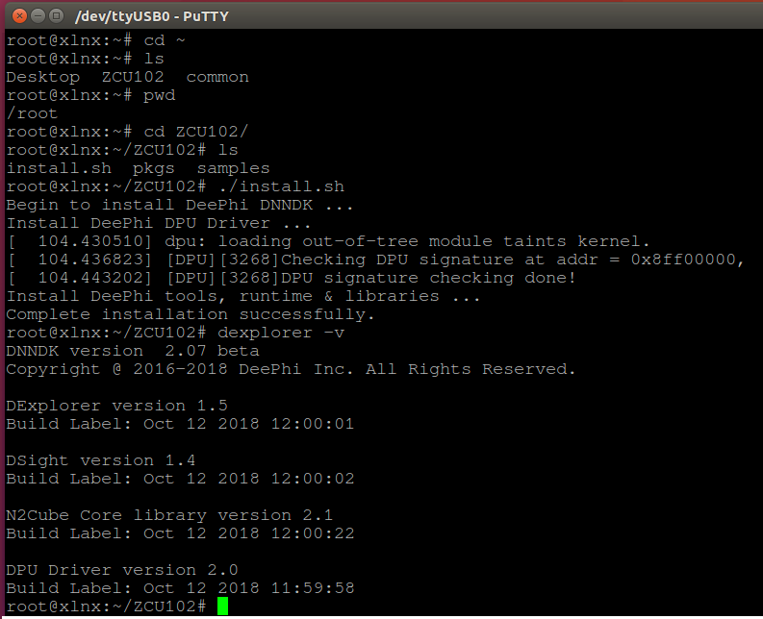

Figure 20: DeePhi DNNDK install on Target board

## **11.1 Installing and running the DeePhi HOST tools on AWS**

**Installing the DeePhi HOST tools on the AWS requires just to copy the executable of **decent**, **dnnc** and **deephi_compress** plus**

**the 3 libraries (**libcudnn.so.7**, **libnccl.so.1**, **libyaml-cpp.so.0.5**) missing on the AWS, then you need to adjust the**

**environmental variables **$PATH** and **$LD_LIBRARY_PATH**. To this purpose I have compiled a shell script named**

**[aet_aws_ML_env.sh](../set_aws_ML_env.sh) which does this work for you, just run it out of**

**any Caffe or TensorFlow virtual environment.**

**Such a script creates on your AWS EC2 a directory named **/home/ML/DNNDK** and then it copies there the 2 tar files named **dnndk_host_libs.tar** and **dnndk_host_tools.tar** that contain a copy of the DeePhi HOST tools taken from the **deephi_dnndk_v2.07_beta.tar.gz** archive.**

**The host tools are placed in a sub dir named **/home/ML/DNNDK/tools** and the 3 missing libraries in the subfolder **~/ML/DNNDK/tools/dnndk_libs**.**

**Note that GitHubEnterprise does not allow to store files larger than 25MB, therefore I had to split the archive of missing libraries **dnndk_host_libs.tar\*\***

**in chuncks of 23MB size: [dnndk_host_libs.tar.parta*](../deephi_host_tools/) with the Linux command**

**'''**

**split -b 24M ./deephi_host_tools.tar deephi_host_tools.tar.part**

**'''**

**From now on you can call the HOST tools from any directory in which you are, so that you can execute the [Quantization process](7_Quantization_Of_MiniVggNet.md) or the [Pruning Process](8_Pruning_The_MiniVggNet.md) (then followed by [Quantization again](9_Quantize_The_Pruned_MiniVggNet.md)).**

**Once done that, you can archive the whole directory **~/ML/cifar10/deephi/zcu102** in a tar file and then move it from**

**AWS to your local PC, and finally from your local PC to your ZCU102 board.**

**To check that the Deephi host tools run correctly do the following commands:**

**```**

**source activate_dnndk.sh**

**cd ~**

**decent --version**

**dnnc --version**

**deephi_compress --version**

**```**

**and you should see something like this:**

**```**

**ubuntu@ip-xxx-xx-x-xxx:~$ decent --version**

**decent version 1.2.3**

**Build Label Sep 6 2018 02:38:39**

**Copyright @2016 - 2018 DeePhi Inc. All Rights Reserved.**

**ubuntu@ip-xxx-xx-x-xxx:~$ dnnc --version**

**dnnc version v2.02**

**DPU Target : v1.3.0**

**Build Label: Oct 12 2018 17:35:34**

**Copyright @2016 - 2018 DeePhi Inc. All Rights Reserved.**

**ubuntu@ip-xxx-xx-x-xxx:~$ deephi_compress --version**

**deephi_compress: command line brew**

**Usage: deephi_compress <command> <args>**

**commands:**

**ana run sensitivity analysis**

**compress compress a model**

**finetune finetune a pruned model**

**transform transform a pruned model to a sparsed model**

**stat get ops and params of a model**

**examples:**

**deephi_compress ana -config config.prototxt**

**deephi_compress compress -config config.prototxt**

**deephi_compress finetune -config config.prototxt**

**deephi_compress transform -model float.prototxt -weights sparsed.caffemodel**

**deephi_compress stat -model deephi.prototxt**

**```**

**### WARNING ###**

**\*\*NOTE THAT IN NO WAY YOU CAN GIVE A CUSTOMER THE PRUNING TOOL. CUSTOMERS HAVE TO PAY A LICENSE FEE FOR THAT.**

**You find here the pruning tool ONLY FOR YOUR TECHNICAL EDUCATION**.**

**### Conclusion ###**

**To see the summary of all this journey with miniVggNet click [here](11_MiniVggNet_Summary.md).**

**FROM CIFAR10 TUTORIAL**

If you work on an AWS AMI, I have created a script [set_aws_ML_env.sh](../set_aws_ML_env.sh) that should setup the environment for you and then launch the whole caffe flow.

You should execute the following commands:

```

mkdir ~/ML

unzip ML-CIFAR10-Caffe-tutorial-matser.zip

mv ML-CIFAR10-Caffe-tutorial-master cifar10

cd cifar10

source set_aws_ML_env.sh

```

You should see something like what shown in this screenshot ![asw screenshot](./images/pc_setup.png)

If you have your own local PC, I have created a script [set_pc_ML_env.sh](../set_pc_ML_env.sh) that should setup the environment for you.

You should execute the following commands (from your caffe virtual environment in order to have the $CAFFE_ROOT variable properly set):

```

mkdir ~/ML

unzip ML-CIFAR10-Caffe-tutorial-master.zip

mv ML-CIFAR10-Caffe-tutorial-master cifar10

cd cifar10

source set_pc_ML_env.sh

```

as illustrated in this screenshot ![pc screenshot](./images/pc_setup.png).

In case you do not have a personal Ubuntu 16.04 laptop or desktop, I have extracted the [DeePhi HOST tools](10_DeePhi_Host_Tools_On_AWS.md) from the **deephi_dnndk_v2.07_beta.tar.gz** archive - which I mentioned in the [Pre-requisites Section](2_Pre-requisites.md) - so that you can install them and run on the AWS EC2 directly. Please follow carefully the instructions provided.